**Invitation to cooperate with the APEC Cooperative Network for Sustainable Cities CNSC**

Dear Mayor, Governor, Regent,

APEC Cooperative Network of Sustainable Cities (CNSC) is an important realization of the Asia-Pacific Urbanization Partnership Initiative, adopted at the 2014 Summit of APEC Leaders. The CNSC was formally established at the 51st APEC Energy Working Group (EWG) Meeting in Canberra, Australia, in May 2016. The purpose of the CNSC is to contribute to the fulfilment of both APEC Energy Goals: reduce APEC energy intensity by 45% from 2005 levels by 2035, double the share of renewables by 2030, and to contribute to the sustainability of its members to attain local Sustainable Development Goals (SDGs), especially SDG 7 (Affordable and clean energy) and SDG 11 (Sustainable cities and communities).

APEC Sustainable Energy Center (APSEC) has been designated as the official implementation agency for the Partnership Initiative. APSEC was established at the 11th APEC Energy Ministerial Meeting in 2014, which was also mentioned in the 22nd APEC Leaders’ Declaration in November 2014. APSEC is the only APEC energy research center focusing on sustainable energy.

Hereby I would like to formally invite your city, province, municipality, regency or town to start cooperating within the CNSC. It would be beneficial if the Municipality could participate in APEC-funded projects such as the one called “Data Driven Carbon Neutral Disaster Resilient Cities” which has been proposed by China and co-sponsored by eight APEC economies. In a first phase (planned for the fourth quarter 2022), this project trains planning officers of the participating regional or local entities to use a multistakeholder dialogue (MSD) to elaborate a long-term vision identifying the most important deficits, including for attaining carbon-neutrality. In a second phase (planned for 2023) it sets up the MSD, elaborates this vision and starts identifying sustainability and disaster resilience deficits and set relevant improvement targets for 2030, taking into account the specific development situation of the regional or local entity.

The CNSC is the ideal network for regional or local entities that do not want to be left behind in the growing momentum of global efforts undertaken to work towards carbon neutrality.

The attachment gives further information. For any questions you may have, please contact Prof. DEFILLA Steivan, [steivan@tju.edu.cn](mailto:steivan@tju.edu.cn) , Fax: 0086 22 2740 0847.

Best regards

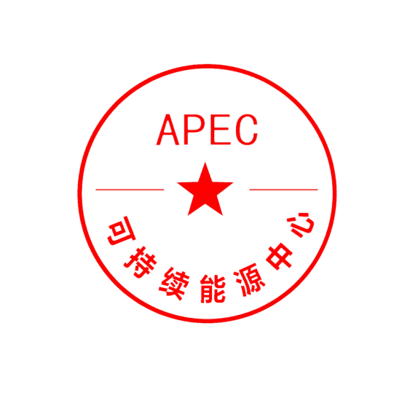

Li Zhu, President,

APEC Sustainable Energy Center, Tianjin, China

Copy:

Annex：Membership Declaration for Provinces, Cities, and Municipalities

Annex：

**Membership Declaration for Provinces, Cities, Municipalities, Regencies and Towns**

**I. Introduction**

APEC Cooperative Network of Sustainable Provinces, Cities, Municipalities, Regencies or Towns is an open, shared, fair and cooperative partnership initiative servicing regional and local entities of the 21 APEC economies. APEC Sustainable Energy Center (APSEC), established at the 11th APEC Energy Ministerial Meeting in 2014, has been designated by APEC Leaders as the official implementation agency for the partnership initiative.

**II. Purpose**

The purpose of the CNSC is to contribute to the sustainability of its Members by cooperating with them to attain both APEC energy goals (reducing energy intensity and doubling the share of renewable energy) which are also mirrored in Sustainable Development Goal (SDG) 7 (Affordable and clean energy). With increasing climate disasters, disaster resilience is being recognized as an indispensable support to SDGs. One of the best ways of cities and local communities to support sustainability is to implement disaster resilience. Disaster resilience is part of SDG 11 (Sustainable cities and communities).

Specifically for cities, the UN has also adopted the Disaster Resilience Scorecard for Cities in 2017. Progress on both, the SDGs as well as on disaster resilience is assessed with the set of indicators defined by the UN. For the SDGs, see <https://unstats.un.org/sdgs/indicators/indicators-list/>, for the Disaster Resilience Scorecard for Cities, more information can be found on <https://mcr2030.undrr.org/disaster-resilience-scorecard-cities>.

**III. Main Activities**

CNSC Members elaborate local **Visions** for guiding them towards more sustainability and disaster resilience, including towards a carbon-neutral future. For this purpose, they are assisted by APSEC or a designated qualified contractor and organize multistakeholder-dialogues (MSD) enabling all actors to contribute to the transition towards sustainability through engagement, information sharing, access to finance, and capacity building. Participants of the MSD become Members of the APEC Sustainable Services Network. To underline the commitment of the CNSC Member to the Vision, the Member will hold the plenary MSD meetings in a Town Hall, wherever this is feasible, and delegate a high-level representative to open and close the plenary MSD meeting. The description of the Vision and the functioning of the MSD is explained here (<http://apsec.tju.edu.cn/index.php/En/Xiangmu/article/id/51.html> ).

CNSC Members nominate a CNSC **Focal Point**, designating a senior executive officer or senior planning officer who represents the Member at the CNSC and chairs the MSD. In case of persistent impossibility to generate consensus among MSD stakeholders on a specific question, or persistent disagreement among the MSD stakeholders on that question, the Focal Point will decide on that question.

CNSC Members identify **sustainability and disaster resilience** **deficits** and **collect relevant data** to monitor improvements. For this they are being assisted by APSEC or a designated qualified contractor. The data collection can be developed in the MSD framework by cooperation with energy-selling enterprises, or within a smart city concept in cooperation with the local infrastructure operators, or by incentivizing local citizens, especially in cooperation with Universities, to collect data with their APPs. For CNSC, a set of relevant local data has been identified and a data base called APEC City Stats has been prepared, see <http://apeccitystats.tju.edu.cn/client/homePage>.

CNSC Members **elaborate business-as-usual scenarios** (BAU) for certain key variables such as population, energy, emissions, GDP. For this task they are assisted by APSEC or a designated qualified contractor.

CNSC Members **pledge** to work towards sustainability and disaster resilience, including for emissions, by setting intermediary targets relating their development to the SDGs for 2030 and long-term targets for mid-century. They identify advantages for their community in contributing to SDGs.

CNSC Members **plan** to take measures in view of working towards attaining the set sustainability targets, including for emissions. Within the first year of joining CNSC, they **proceed** to state what actions they will take in the short term and long term. For this task, they are assisted by APSEC or by a designated qualified contractor and can profit from exchange of experience with other CNSC Members.

CNSC Members **publish** progress against the set short-term and long-term targets and **evaluate** measures taken and adapt them if necessary. For these tasks they are assisted by APSEC or by a designated qualified contractor.

CNSC Members may participate in **technology transfer** as organized by APSEC or a designated qualified contractor. APEC Energy Working Group showcases technologies in the Energy Smart Communities Initiative Knowledge Sharing Platform (ESCI-KSP), see <https://www.esci-ksp.org/>

CNSC members will be assisted to **participate in APEC city awards** once such awards are being organized

**IV. Benefits**

Receive assistance for carrying out the following tasks:

Elaborating a local Vision guiding the Member towards sustainability, including carbon neutrality

Collecting SDG-relevant data, including data relating to disaster resilience

Elaborating business-as-usual scenarios (BAU)

Planning measures and proceeding to taking actions in view of attaining sustainability

Publishing progress reports against the set targets and for evaluating the measures

Participating in technology transfer for clean and sustainable technologies

Participating in APEC city awards once these have been decided

Making projects bankable.

**V. How to join the network**

The undersigned ____________________________ (family name, first name) in his quality of _______________________________________ (title) of the local administration of _________________________________ (Province, City, Municipality, Recency, Town) in the APEC economy of _____________ postal address __________________________________________________ e-mail _______________________________________________________ complete mobile phone number _____________________________________ fax ________________________________________________________ name of an assistant ______________________________________________ e-mail of an assistant __________________________________________ hereby certifies having taken note of this Membership Declaration and having received approval in principle from the Head of his local administration to be Focal Point, i.e. Chair of the MSD, and contact point of his city to the Cooperative Network of Sustainable Cities CNSC. The undersigned will make best efforts to cooperate in the CNSC according to the modalities stated in this Membership Declaration. In case of discontinuation, the undersigned commits to inform APSEC Prof. DEFILLA Steivan by e-mail [steivan@tju.edu.cn](mailto:steivan@tju.edu.cn) .

Signature: _____________________

Date: _________________